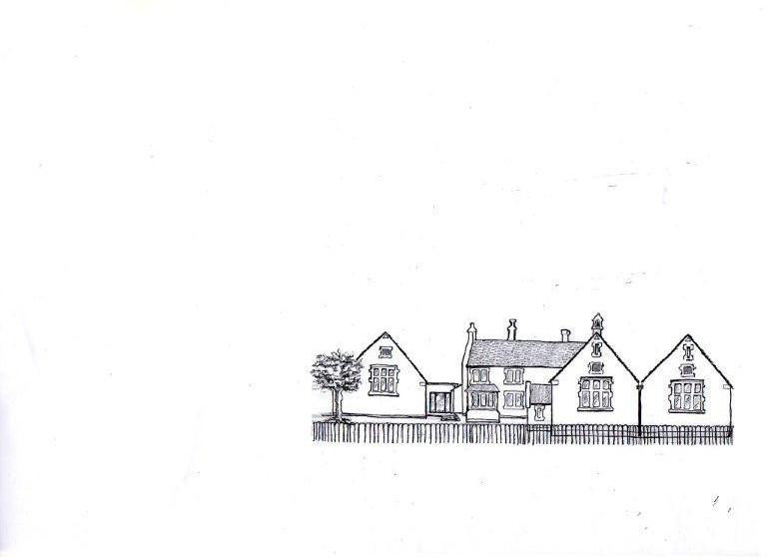
School Lane
Whitminster
Glos
GL2 7PJ
Telephone: 01452 740406
admin@whitminstercofe.gloucs.sch.uk
www.whitminstercofe.gloucs.sch.uk
Head Teacher: Mrs L Hinkley

WHITMINSTER ENDOWED C OF E PRIMARY SCHOOL
A FAMILY, A FOUNDATION, A FUTURE

Dear Parents/Carers

Please find below instructions to set your child up with a username and password for Google Classrooms. This is a DFE funded resources to support remote learning. Please spend some time with your child using this resources and discovering the work the teachers have set. Please note that our Whitminster google space is private. We have:
- Created Google Classrooms for all class groups
- Set up Google Meet (video calling) so that:
- Only teachers can create video calls and initiate recording
- Students can only join video calls
- Disabled Gmail for all users
- Prevented students from sharing or receiving files from external users
- Blocked students from being able to install any apps from the Chrome Web Store
- Turned off all additional services for student users

TO ACCESS GOOGLE CLASSROOM
To access a username and a temporary password please visit http://tiny.cc/WhitminsterGSuite
You need to enter your child’s first and last name and their date of birth (format DDMMYY) then click on
GET CREDENTIALS

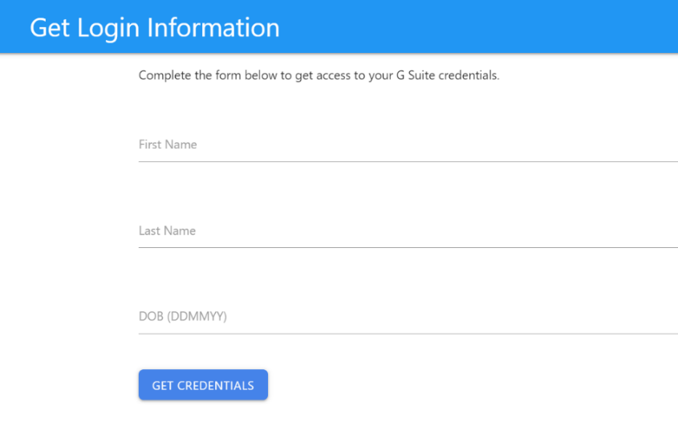
Then go to google homepage and sign in.

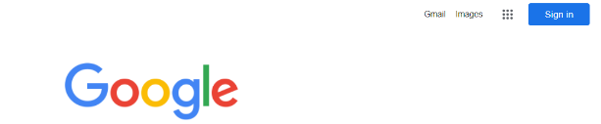

You can change your password using the following:

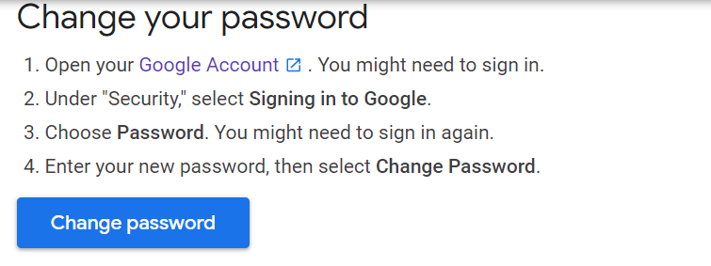

Click on the Apps and find Google Classroom

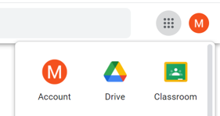

Here you will find a to do list and tasks set by your teacher

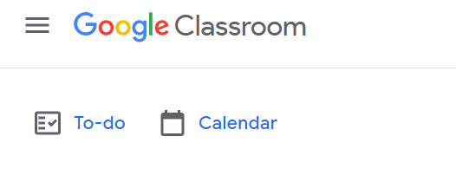
Children will all join their school 'Classroom' in school, so do not need a joining code or to do anything specific to gain access at home. Children just need to make sure that they are logged into their own Google account (home devices may default to other accounts) and their Classroom will be accessible.
We would suggest that after accessing your child's classroom, you and your child familiarise yourself with the platform together. There will be a range of 'assignments' posted and some of the tasks can be uploaded/completed online for the teacher to view.
Tasks (assignments) for the children to complete will be posted regularly. If you miss any, do not worry as they remain in the classroom.
Please also find attached a detailed guide for parents. Any problems please let us know.

